Hey guys,

I thought I’d take some time to make a quick document to go over some of the assembly and what parts have gone missing. I will explain how to replace these parts. If you do, I’d really appreciate if you forwarded the documents to me so I could more easily share the files. Just flick a message at u/moaeater on reddit and I’ll really appreciate it. I will mention 3d printing a lot. I understand that’s not possible for everyone so always remember that cardboard can achieve the same thing. Thanks.

## Missing

1. The “Tracks”.
   1. The three tracks iron throne, fiefdom, and king’s court are a communal area displaying where people’s influence lies.
   2. Replace by printing/3d printing an iron throne, a sword, and a raven.
   3. Replace by creating 3 grids numbered 1 through 12. The iron throne and fiefdom track are just numbers. The kings court track will have 1 through 12 but will also have a number of stars related to how which number with 1 having the most and 12 having the least. They are as follows 5, 5, 4, 4, 3, 3, 3, 2, 2, 2, 1, 1, 0, 0.
      1. If you’re playing with less than 12 players simply block numbers starting from 1 or 12 to speed up or slow down gameplay.
   4. Each house will also need a symbol to represent their standings on the tracks.
      1. Grab the symbol from the back of their cards (in the .psd format) photoshop it out. Print 3 tokens for each house matching the size of the track bits, but not so big to obscure the stars. Print 6 stickers for each house, same size as the stickers, slap em on both sides.

Should look like this, except the tokens in place should be either coloured (uniquely to each house, colour matching the pieces) or have stickers on the back.

Sorry, I do not have these files.

1. The “Money”
   1. Power tokens are small icons that are used as the games currency and to hold lands.
   2. Replace by printing(must be on cardboard/3d printing 240 small rectangles about 1cm x 2cm. Then print 40 stickers of the same size with the house symbol on them. Stick the stickers or glue the paper onto the rectangles.
      1. Because the money is used to hold lands, it must unique to each house.
      2. Use the same symbols from the track tokens. Just resize them to make it fit the smaller icon.
2. The “Orders”
   1. Orders are the most fundamental part of the game. They move things and collect recourses.
   2. Replace by using my word doc to print the face, and another word doc to print the house sigils for the other side. Some are missing, but can be easily replicated using the extracted symbols mentioned twice earlier.
      1. There are bonus orders to speed the game up, I do not have the files anymore, but I can ask around with my co creators from years ago to get them back. Please only consider this after building the whole game.
3. The “Army”
   1. The army is important for conquering and holding land.
   2. Replace by buying the official boardgame twice and just recolour all the pieces in the second box (that’s what I did) or 3d printing your own to the same ratios.
      1. We were considering a “Battle Boat” 3 atk, 1 def. It slowed the game down very heavily in play test though.

Shown here in my friend’s high production value version. Sidenote: Dragons replacing siege towers cause dragons are cooler than siege towers.

Again, I don’t have these files, I just used the official pieces twice.

1. Stickers for the “Cache”, “Castles”, and “Barrels”
   1. In the folder are some sketchup files. Castle, Barrel and Order Cache.
   2. Each one should be printed twelve times and have stickers on it denoting it to a certain house
2. The starter slide.
   1. The Cache should have a starter slider that obscures other players view of orders and money whilst telling you your starting positions.
   2. It should look like this. You need to print out the paper thing. Basically each house starts where they start.
      1. Nights Watch. Knight+Foot in The Haunted Forest. Foot in Fist of the First Men. Boat in Bay of Seals.
      2. Stark. Knight+Foot in Winterfell. Foot in White Harbor. Boat in The Bite.
      3. Greyjoy. Knight+Foot in Pyke. 2 Boats in Ironman’s Bay.
      4. Lannister. Knight+Foot in Lannisport. Foot in Golden Tooth. Boat in The Golden Sound.
      5. Baratheon. Knight+Foot in Dragonstone. Foot in Cracklaw Point. Boat in Blackwater Bay.
      6. Tyrell. Knight+Foot in Highgarden. Foot in Horn Hill. Boat in Redwyne Straits.
      7. Martell. Knight+Foot in Sunspear. Foot in Salt Shore. Boat in Stepstones.
      8. House of B and W. Knight+Foot in Braavos. Foot in Braavosi Coast. Boat in Bravoosi Bay.
      9. Blackfyre. Knight+Foot in Volantis. Foot in Selhorys. Boat in The Smoking Sea.
      10. Targaryen. Knight+Foot in Meereen. Foot in Yunkai. Boat in Slaver’s Bay.
      11. Dothraki. Knight+Foot in Ibben (island, I know). Foot in Ra’aki. Boat in Port of Ibben.
      12. Qarth. Knight+Foot in Qarth. Foot in Yi Ti. Boat in The Jade Sea.

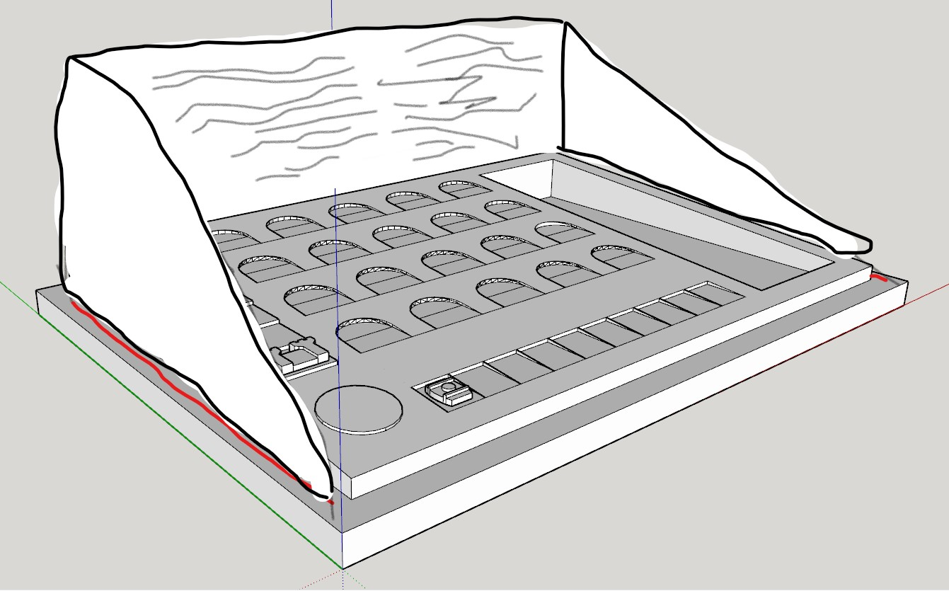  
If anyone wants to give me cool graphics for these that would be great.

# Assembly

## The Board

Break the board into four equal quadrants using Photoshop or some other program. Export as the highest quality .JPEG.

Print onto four sturdy A0 pieces (this actually will cost a lot weirdly).

Buy four pieces of A0 backing and glue the printouts to them. Try to avoid any bezels where maps intersect. Try to avoid air bubbles.

The skulls are areas where if you spend for than one round in, you lose 1 unit per round. They can be held with power.

## The Cards

Using Cards Fix print the fronts. Print the backs. Glue them together. I was able to get these printed like trading cards. In a big city this is possible.

Buy the official game for the main setting cards and wilding cards.

## The Tokens

Set a full day aside to cutting/gluing. Print em all. Glue em all. Or 3d print it using coloured filaments for each house.

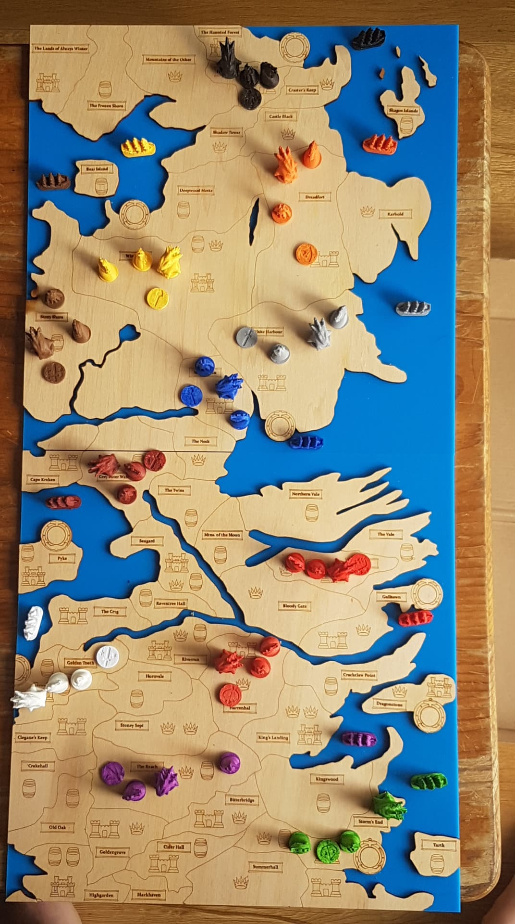

Happy gaming. Here’s a pick of my friend’s laser cut, 3d printed version if you’re a bit a creator, this is possible.

Remember with criticism that this was made by bunch of (really talented) university students and not professional game makers or artist. We learnt photoshop on the fly and play tested to find errors.

Good luck and just message me at u/moaeater for questions and queries.

P.S if anyone is based in Melbourne, give me a holler.